**Solution**

part 1

#include <stdio.h>

void main()

{

printf("A B C D E F");

getch();

}

Exemple d’exécution :



part 2

#include<stdio.h>

void main()

{

int n = 13;

printf("\* \* %d \*\*", n);

getch();

}

Exemple d’exécution :

C:\Users\asaid_000\AppData\Local\Microsoft\Windows\INetCache\Content.Word\test 2.1.png

#include<stdio.h>

void main()

{

int n = 7;

float b = 1.1;

printf(" \* \* %f \*\*", n\*b);

getch();

}

Exemple d’exécution :



#include<stdio.h>

void main()

{

const int k = 15;

int n;

double g, s = 1;

printf("un entier puis un double : ");

scanf("%d%lf", &n, &g);

printf("\* \* %d \*\* %lf \*\*", n, g);

s = g\*s + k;

printf("\* \* %lf \*\* ", s);

getch();

}

Exemple d’exécution :

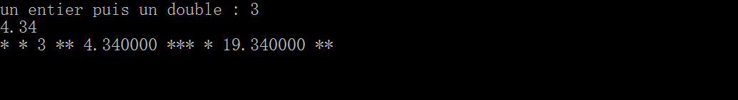

#include<stdio.h>

void main()

{

int i, j;

printf("deux entiers : ");

scanf("%d%d", &i, &j);

i = ++j;

printf("i = %d, j = %d \n", i, j);

i = j++;

printf("i = %d, j = %d \n", i, j);

j = ++i + 5;

printf("i = %d, j = %d \n", i, j);

j = i++ + 5;

printf("i = %d, j = %d \n", i, j);

getch();

}

Exemple d’exécution :

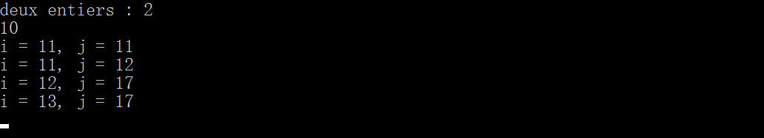

***TP1 plus***

***Control of output***

Sense this is the first TP we have some free time to learn something about customizing execution screen right click at the up bar of application and check them.

Right click on the bar

1

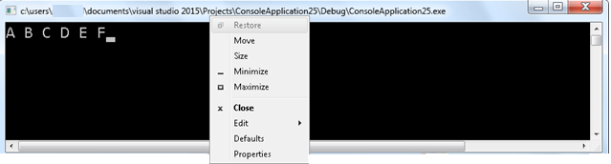

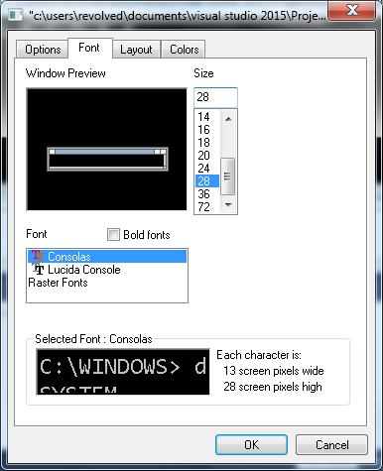

Press Ok when you finish to apply and see change

Change font size

Change font type

Choose Proprieties

2

**About Font:**

**Tips for output color look:**

* make screen background white
* Screen text black

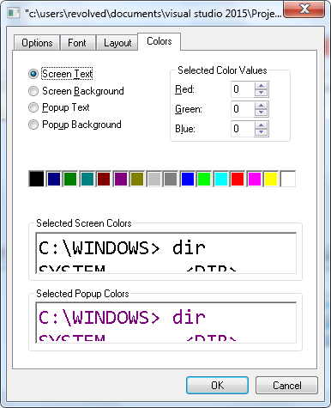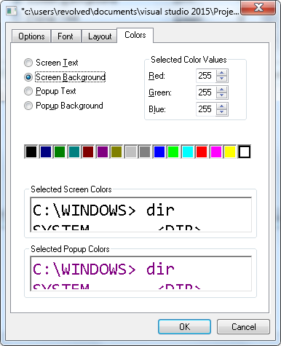

And click ok.

Before:

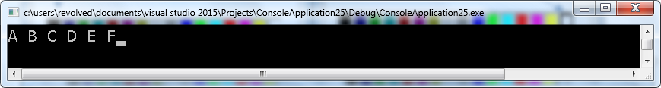

After:

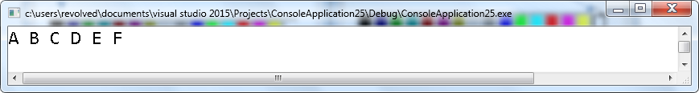

**Output to text:**

Other wise to copy output to clipboard and paste else where do the following:

* Right click on the up bar >> Edit >> Select All >> press Enter >> paste it where ever you want (ctrl + v).
* Or right click on the black screen >> Select All >> Enter.
* Or just select text on screen with mouse while holding left button then right click

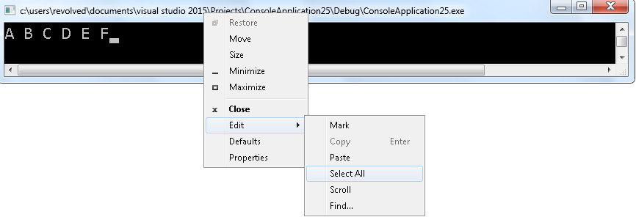

* Note: in this book from now and after, examples on execution output will be shown as text inside a black box with no fill.

And here is the output as text « **A B C D E F** ».